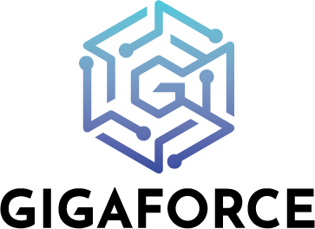

Position: Sr Java Lead Engineer
Location: Noida
Department: Engineering
Employment Type: Full-time (5 days in office)
Function: Software development (Dev)
Primary Interface: Engineering, AI Teams, and Executive Leadership
Work Style: Agile, cross-functional, outcome-driven, and detail-oriented

About Gigaforce
Gigaforce is a global insurance technology company transforming the property and casualty claims ecosystem through Artificial Intelligence (AI), intelligent automation, advanced analytics, and carrier collaboration platforms. Its flagship solutions, including SubroScore, ClaimMatch, and Subroforce, help insurers identify recovery opportunities, automate workflows, improve operational efficiency, and maximize financial outcomes.

We are looking for an experienced Java professional who is passionate about building scalable, cloud-ready enterprise platforms. The ideal candidate should possess strong hands-on coding skills along with experience designing distributed systems, microservices, and event-driven architectures.

We are seeking engineers who think beyond coding—individuals who can design robust systems, solve complex engineering challenges, and contribute to the long-term technology vision of the platform. The ideal candidate should combine strong hands-on development expertise with architectural thinking, a product mindset, and a commitment to engineering excellence.

This role requires an individual who can contribute across the entire software development lifecycle—from solution design and architecture to implementation, deployment, and production support—while mentoring engineers and driving engineering excellence.

This is a hands-on engineering role requiring strong technical expertise rather than team management.

Key Responsibilities:
- Design and develop highly scalable, secure, and resilient enterprise applications.
- Build and maintain microservices using Spring Boot and the Spring ecosystem.
- Design RESTful APIs and asynchronous event-driven services.
- Develop high-performance distributed systems capable of handling large transaction volumes.
- Design and implement messaging solutions using Kafka or equivalent event streaming platforms.
- Work closely with Product, Architecture, QA, DevOps, and Infrastructure teams.
- Lead technical design discussions and perform architecture reviews.
- Drive engineering best practices including coding standards, code reviews, testing, and documentation.
- Identify performance bottlenecks and optimize application performance.
- Participate in production support, troubleshooting, and root cause analysis.
- Mentor junior developers and guide the team on technical solutions.
- Contribute to platform modernization and cloud-native architecture initiatives. Work closely with engineering teams to automate software delivery and infrastructure provisioning.

